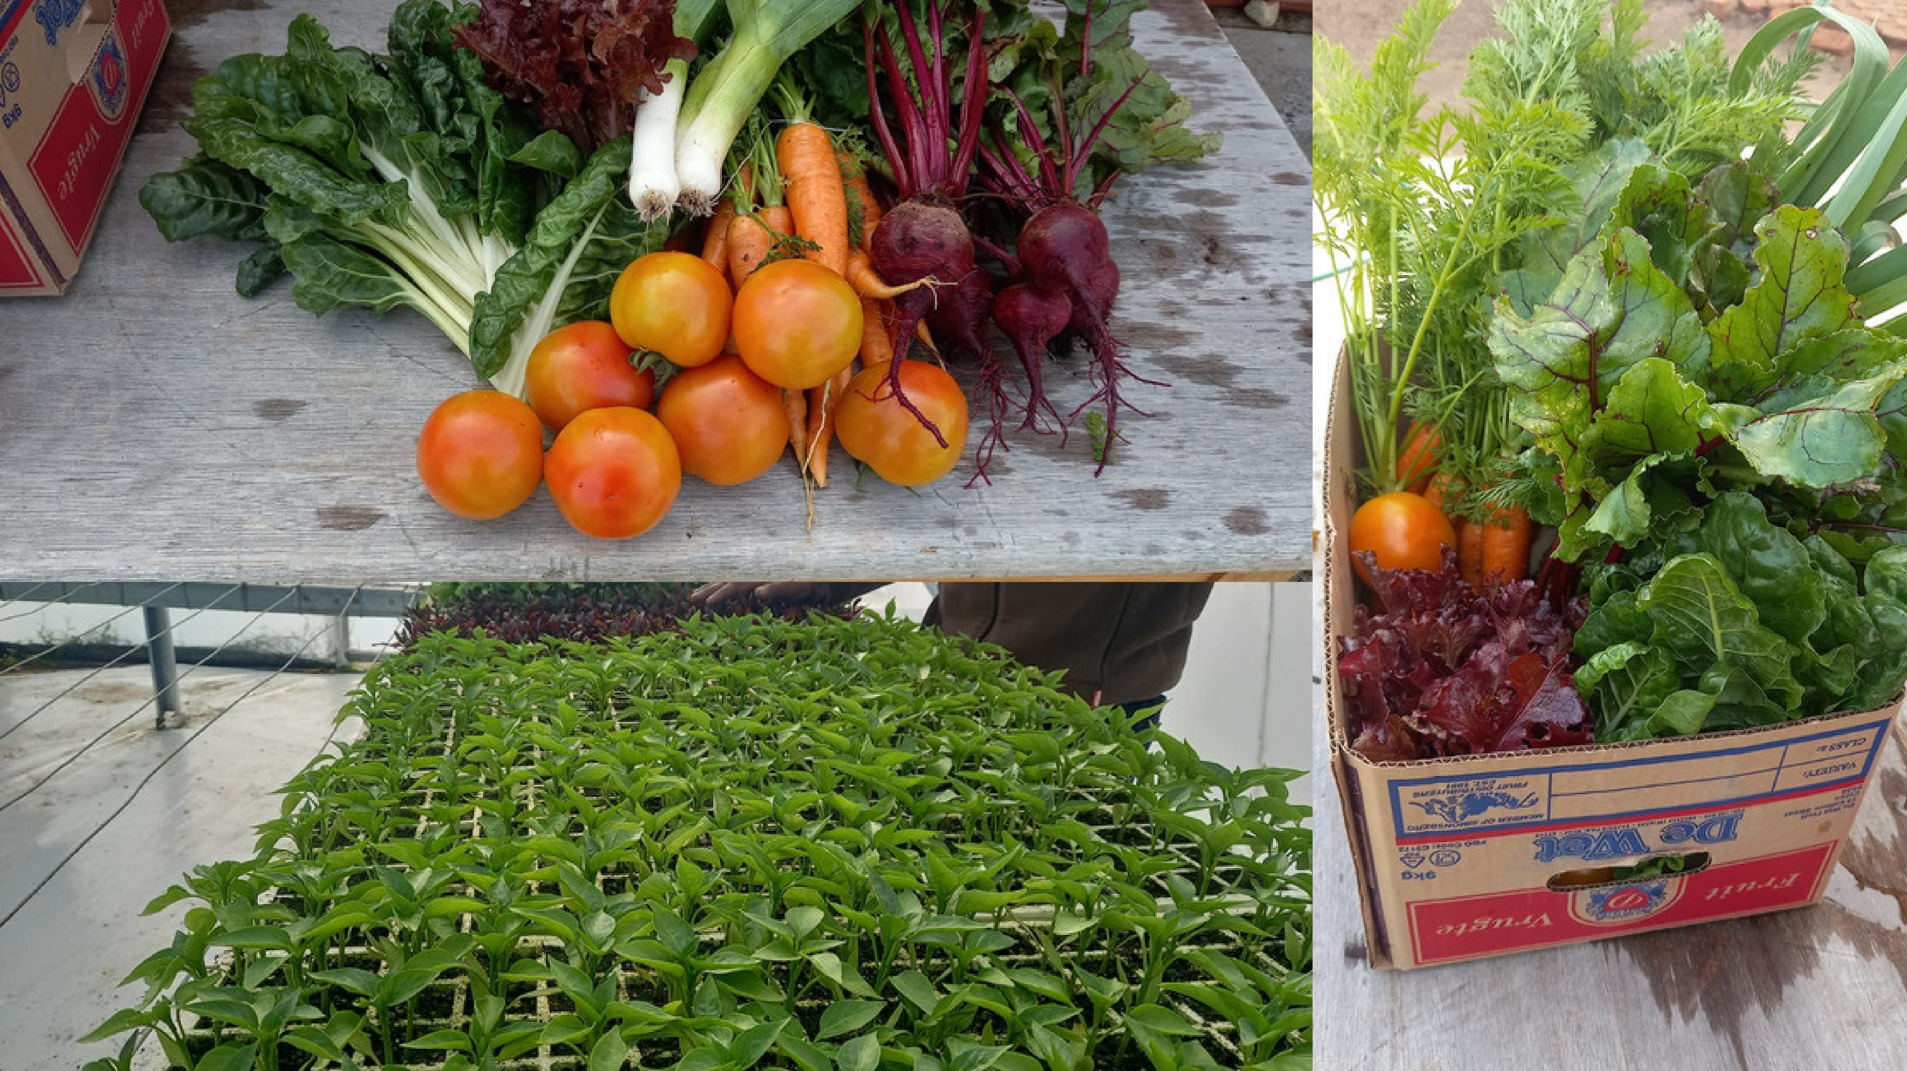
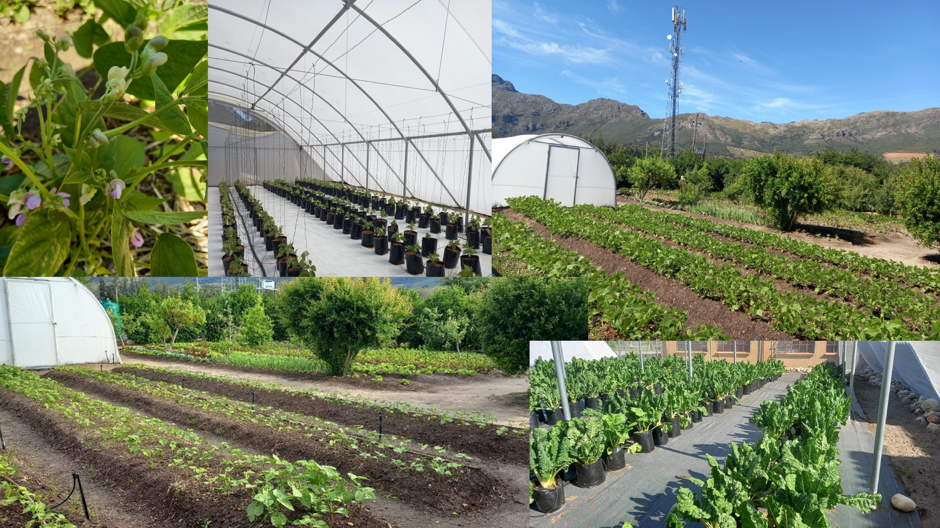
Kylemore Secondary School, Stellenbosch

National School Nutrition Programme garden competition
24 March 2023
Western Cape schools with flourishing gardens recently reaped the fruits of their labour in the form of awards.
A total of 28 schools were finalists in three categories of the provincial National School Nutrition Programme (NSNP) competition.
Participants in Category A were schools with food production projects that are semi-commercial to commercial, schools in Category B have standard sized food production projects, and Category C is reserved for schools in areas that have less precipitation and shallow soils, such as the Central Karoo as well as the northern parts of the West Coast.
De Rust Futura Academy in Grabouw and Kylemore Secondary School in Stellenbosch were the joint winners in Category A. Second place went to Jakes Gerwel Technical School in Bonnievale and Calitzdorp Secondary School claimed the third prize.
Factreton Primary School in Kensington won in Category B with Oker Primary School in Albertinia in second place followed by Blackheath Primary School in third.
Steilhoogte Primary School in Vredendal received first prize in Category C. Excelsior Primary School in Calitzdorp won second position and third place went to Koekenaap Primary School in Lutzville.

De Rust Futura Academy impressed the judges with their large-scale production of green beans, pumpkins, herbs and other vegetables. The school also owns a 25 stud Hereford herd complete with handling facilities.
Kylemore Secondary School credits the acting principal, Tertia Jefthas, the Agricultural Sciences teacher, Mr Vermeulen, and his learners, the project manager, Mr Pienaar, and two gardeners for the success of their garden.
The school grows tomatoes, spinach and green peppers in three tunnels and an open garden dedicated for commercial production. The produce in another section of the garden is used to support the NSNP kitchen. They also have quince and pomegranate trees, but not on a large scale.

